1.What is the correlation (R2 value) between sales and income?
From the Regression Analysis it is found that the correlation between sales and income is 0.78 which predict that that the sales and income are hugely dependent to each other which is about 80%. That means if incomes increase then sales will also increase and vice versa.
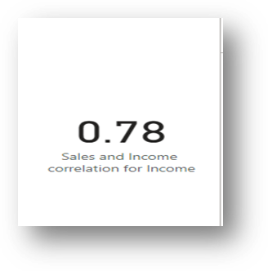
2.What is the correlation (R2 value) between customer ratings and product return rate?
The correlation between customer ratings and product rate is found about 0.50 which is almost 50% of prediction rate. Which means that if a product has low rating the customers have 50% chance of returning the product
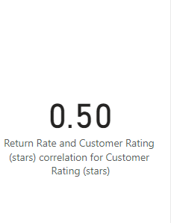
3. What are the linear regression formulas to predict customer sales and customer incomes?
The regression formula used to predict customer sales and income is y = mx + b

4. Which customer do you predict has the highest income?
From analysis it is found that “Jon Little” has the highest income which is almost $453k
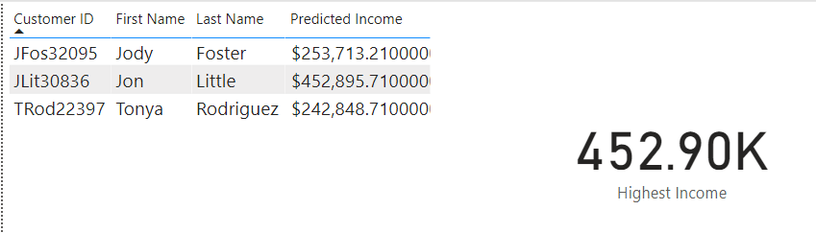
5.Which product will be advertised the most?
As “Chronograph Watch” has highest Customer Rating(4.9) and lowest Return rate (0.00014) its should be advertised most.
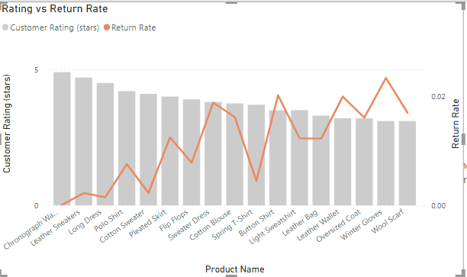

The scatterplot relationships with R-Squared values
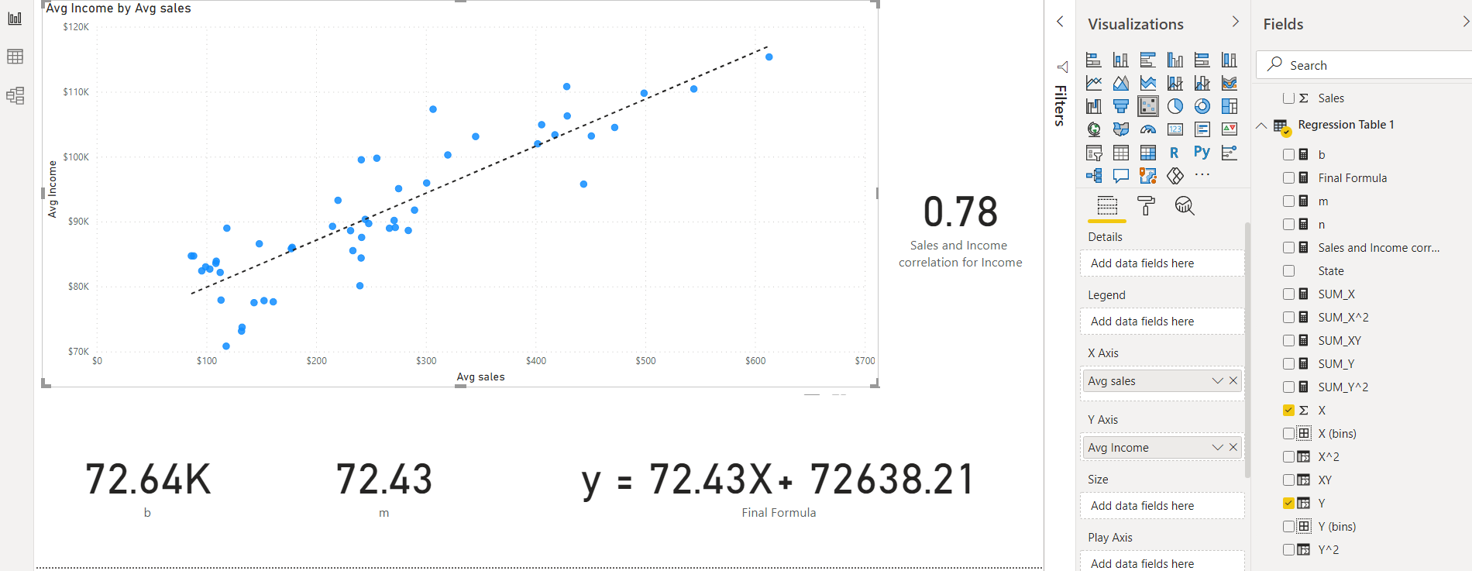
y = mx + b formula was used to predict the customer income. From the scatter plot we can see that if the Avg sales is $300, the Avg Income should be around $95k. If we input x value x = 300 in our Final Formula y = 72.43x + 72638.21 we get $94.37K which is very close to $95k. That’s prove that our prediction is correct.
Findings from the research of 1-2 additional variables
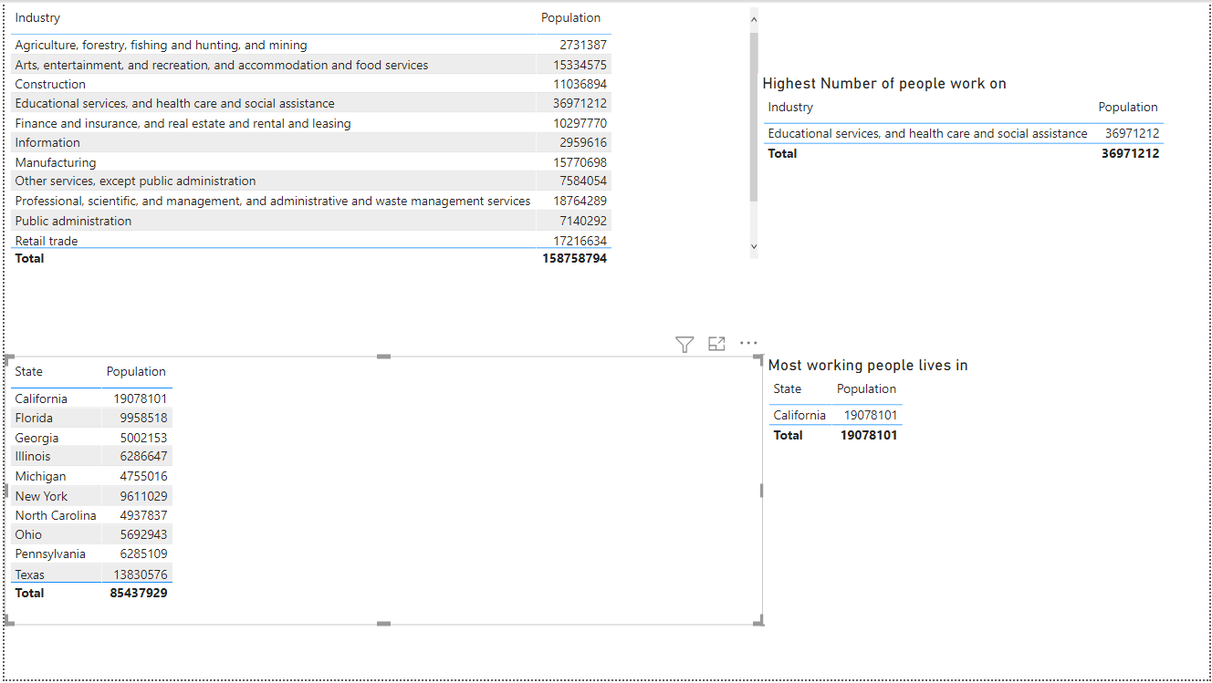
It is found that most people works in Industry “Educational services, and health care and social assistance” sector (36.97M) and these working people mostly lives in California (19.08M).
Marketing strategy
Marketing strategy should focus on California state as California has the highest number of working people .

Final Recommendations
Stock of product, price below $100 should be increased. As these products are affordable to all ranges of customers.

